Pending first-instance asylum cases at highest level since December 2017

* 10TH OCTOBER 2019

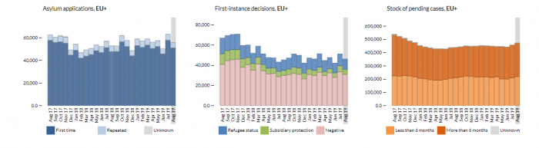

Between January and August 2019, some 456 000 applications for asylum were lodged in the EU+, **up by 10%** compared to the same period last year. The updated figures are in line with the trend seen throughout the year. However, following a peak in July (62 900), **12% less** applications were registered in August (55 400).

The main countries of origin remained **Syria, Afghanistan** and **Venezuela**, all with **fewer applicants than in July** – as was also the case for the majority of the top 30 citizenships of origin. However, some nationalities applied more for asylum than in most other months in 2019, such as Syrians, Afghans and Turks. In a longer-term perspective, between January and August 2019 the majority of the 30 most common citizenships of origin lodged more applications than in 2018.

At the same time, there was a marked **increase in the number of first-instance decisions for Venezuelans, Salvadorians and Colombians**, particularly over the summer. So far, in 2019 these three citizenships have already received as many decisions as in the whole of 2018, in particular Venezuelans (four times as many as in the whole of the past year) and El Salvador (+ 70%). Nevertheless, the overall output of EU+ first-instance authorities is still lagging behind last year’s (- 7%).

At the end of August, there were still some 471 200 applications awaiting a decision in first instance in the EU+, a noteworthy increase – by some 15 000 cases – for a second consecutive month. **This was the highest number of pending cases since December 2017.** In addition, a similar number of applications were awaiting a decision in appeal or review at the end of June 2019, amounting to some 895 760 cases pending at all instances overall. One in five applications pending at first instance in August pertained to Syrian or Venezuelan nationals.

**EASO providing more operational support than ever before**

Earlier this week, the European Asylum Support Office (EASO) [reported](https://www.easo.europa.eu/news-events/over-900-easo-personnel-deployed-operations-four-eu-member-states) that **over 900 personnel** are now deployed in Greece, Italy, Cyprus and Malta to support the national authorities’ asylum services. So far, in 2019 this unprecedented operational support, which accounts for almost **40% of the Agency’s budget**, has seen EASO personnel present in **88 locations** in the four Member States.

For more information and an interactive data visualisation, please visit the [Latest Asylum Trends](https://www.easo.europa.eu/latest-asylum-trends) page.